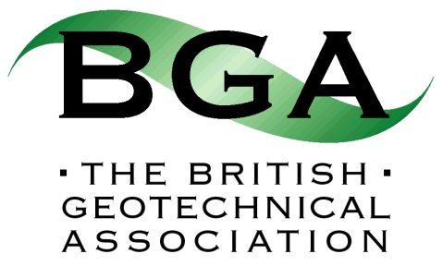

57th Rankine Dinner

Wednesday 15th March 2017 at 7.30pm
Queen’s Tower Room, Sherfield Building, Imperial College London, Exhibition Road, SW7 2AZ

Request Form
(Note: Bookings are not guaranteed until payment has been made by credit card)

Please return to Shelagh Fleming at bga@britishgeotech.org.uk by 31st December 2016

Primary Host | First Name
 | Surname
 | BGA/ICE Membership Number
 | Contact e-mail address
 | Contact telephone
 | Company
 | Address
 | No of individual places required | (maximum = 9)
OR | No of tables (10 places) required | (maximum = 2)
Alternative host for 2nd table if required/available | First Name
 | Surname
 | BGA/ICE Membership Number
 | Contact e-mail address
 | Contact telephone
Booker  (if not host) | First Name
 | Surname
 | BGA/ICE Membership Number
 | Contact e-mail address
 | Contact telephone

